Day 1 Lab Assignments
- Design the home page using HTML5 structural elements, similar to this layout:
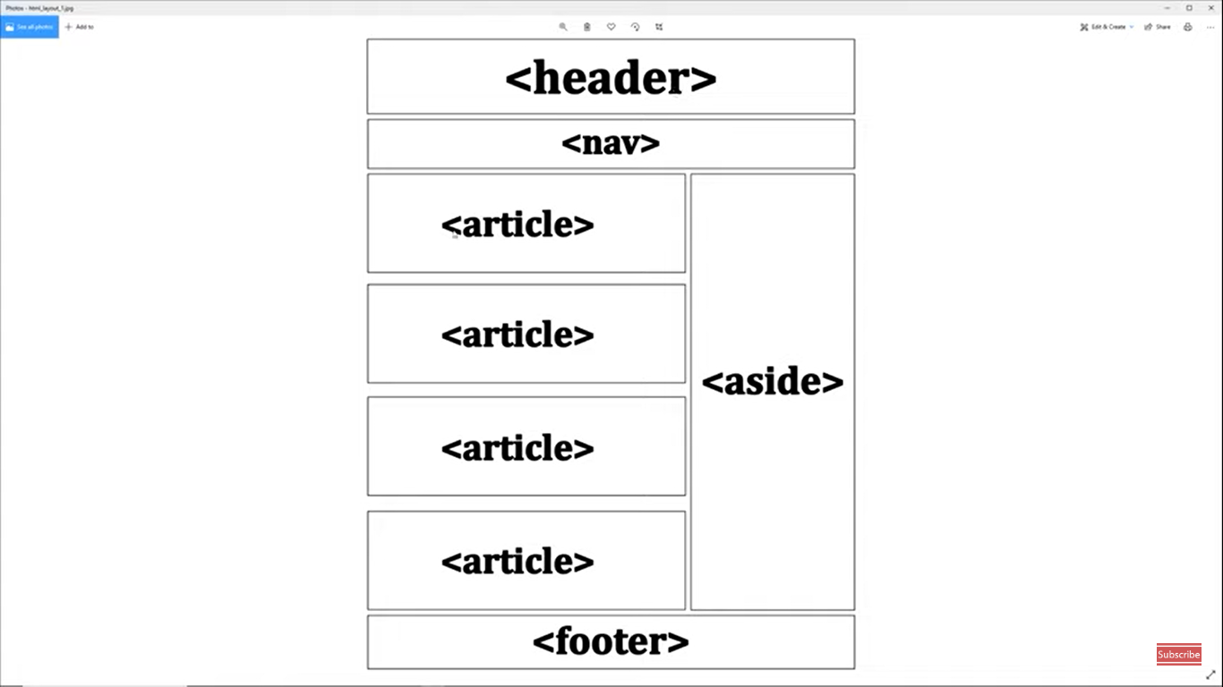

- Make an html5 form with the following requirements
- first name as text with label and placeholder .. make it required.
- last name as text with label and placeholder .. make it required.
- password with label and placeholder .. make it required.
- Telephone input with a label .. make it required.
- BirthDate as input of type date with min date of 2000-01-02.
- range input to represent your skills in html5 course with min 0 and max 10.
- Email input and make it required and autofocused.
- Submit button with post method and redirects to thanks.html page.
- Submit button with get method and without validation and redirects to home.html page.
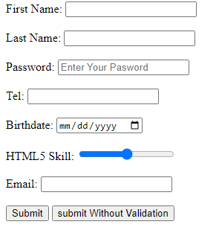
- Try video and audio of any example you want on your page.

- (Bonus) Make a simple CV with skill bars indicating your skills (use the meter), as the following:
  - Use a meter for the skills section, and make it circles.

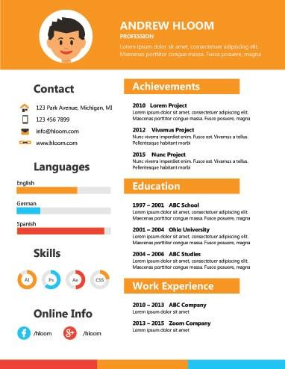


<Thank>YOU </Thank>

